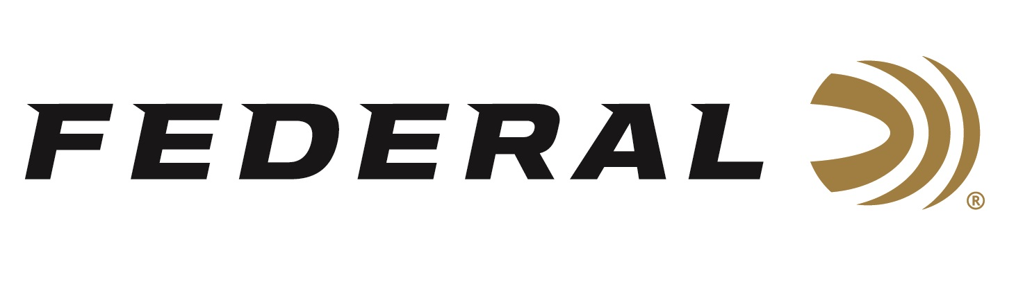

FOR IMMEDIATE RELEASE

“It’s Federal Season” Joins the Talk North Podcast Network

ANOKA, Minnesota – April 22, 2021 – Federal Ammunition’s podcast “It’s Federal Season” teams up with the Talk North podcast network, the premiere sports and outdoor podcast network in the Upper Midwest. By joining Talk North, Federal is expanding its reach with a relevant audience that consumes sports and outdoors entertainment and information via a podcast.

“Talk North currently produces and hosts eighteen different sports and outdoor lifestyle podcasts with some of the top hosts, experts and influencers in their respective industries,” said Talk North CEO and partner Scott Fransen. “Having the world leader in ammunition manufacturing part of our line up enhances our outdoors content and educates a passionate audience in the Upper Midwest.”

“This is a great platform for our podcast,” said Brian Kelvington, Federal’s Director of Media. “There is obvious synergy with existing programs like The Flush and Reverend Hunter on the network, and we know those audiences and more will enjoy listening to the ammunition focused content.”

“It’s Federal Season” podcast has discussions with outdoor celebrities, leading experts in ammunition design and manufacturing, addresses industry current events, and educates audiences on new products that benefit shooters at the range or in the field.

Fans of “It’s Federal Season” can find the podcast at www.TalkNorth.com or continue finding it at https://www.federalpremium.com/this-is-federal/its-federal-season/.

Federal Ammunition can be found at dealers nationwide or purchased online direct from Federal. For more information on all products from Federal or to shop online, visit www.federalpremium.com.

Press Release Contact: JJ Reich
Senior Manager – Press Relations
E-mail: VistaPressroom@VistaOutdoor.com

About Federal Ammunition
Federal, headquartered in Anoka, MN, is a brand of Vista Outdoor Inc., an outdoor sports and recreation company. From humble beginnings nestled among the lakes and woods of Minnesota, Federal Ammunition has evolved into one of the world's largest producers of sporting ammunition. Beginning in 1922, founding president, Charles L. Horn, paved the way for our success. Today, Federal carries on Horn's vision for quality products and service with the next generation of outdoorsmen and women. We maintain our position as experts in the science of ammunition production. Every day we manufacture products to enhance our customers' shooting experience while partnering with the conservation organizations that protect and support our outdoor heritage. We offer thousands of options in our Federal Premium and Federal® lines-it's what makes us the most complete ammunition company in the business and provides our customers with a choice no matter their pursuit.

